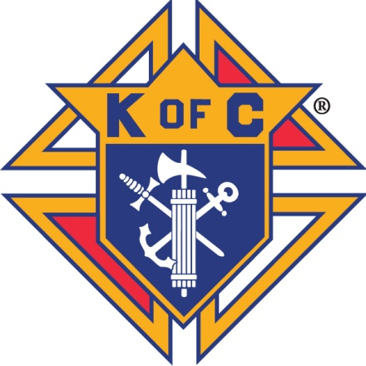
Knights of Columbus
Our Lady of Lourdes Council 5890
Washingtonville, NY 10992
845 496 -3301

To the Parents

The enclosed information is to assist the Washingtonville Knights of Columbus in selecting a deserving catholic child to make a pilgrimage to the shrine of Our Lady of Lourdes, in Lourdes France. Please read carefully

The age of the child must be between 1 and 19

All children under the age of 19 must be accompanied by a parent or guardian.

Children who use wheelchairs are accepted on this pilgrimage. Unfortunately, due to airline restrictions, stretcher patients and those with oxygen tanks cannot be considered.

This pilgrimage is accompanied by an experienced medical staff and volunteers.
They are there to provide assistance. They do not supply equipment, special foods, or medications. These items must be provided by the family of the child.

A medical form must be completed for each child and must be reviewed by our medical staff to determine if the needs of the child can be met during our pilgrimage.

A letter from the child’s physician must be submitted stating that the child can join the pilgrimage or the physician must sign the application, which will be provided to you.

All Medical forms must be completed and submitted to the representative of the Knights of Columbus, Our Lady of Lourdes council, who will forward it onto the U.S. National Rosary Lourdes Pilgrimage Office no later than February 28

A photo of your child is required for newspaper and Knights of Columbus articles and internet postings on the council webpage and other sites. A school picture scanned as a .jpg is preferred not .pdf or you can provide a wallet sized picture and we will scan it ourselves.

A brief biography of the child is requested. This is for internal use only as we will only disclose the child’s name, age, parish and illness.
The father of the prospective candidate need not be a member of the Knights of Columbus.

The Knights of Columbus will handle all transportation and lodging accommodations.

If the child selected for the pilgrimage cancels 60 days or more prior to departure, an alternate child shall take the pilgrimage.

If a child selected for the pilgrimage cancels less than 60 days prior to departure, the chairman and co-chairman with the approval of the Grand Knight will decide if there is sufficient time to send an alternate child.

There is no monetary award if a child declines to go or cannot participate on the pilgrimage for whatever reason.

All reasonable expenses regarding transportation, hotels and meals will be paid for by the council and one parent only. Transportation to and from local airports (JFK or Newark Liberty) will be provided from the council in Washingtonville, NY. If you decide to get to and from the airport on your own, this cost will not be paid for by the Knights of Columbus.

Costs specifically not paid for by the Knights of Columbus include: cost of passports, spending money, medicines, clothing, and special equipment for the child, beverages at meals with the exception of juice, milk, coffee, and tea which is provided at breakfast only, and any other items not noted in the itinerary. Non bottled water is provided at all meals.

